**Project 2: Twitter Trends**

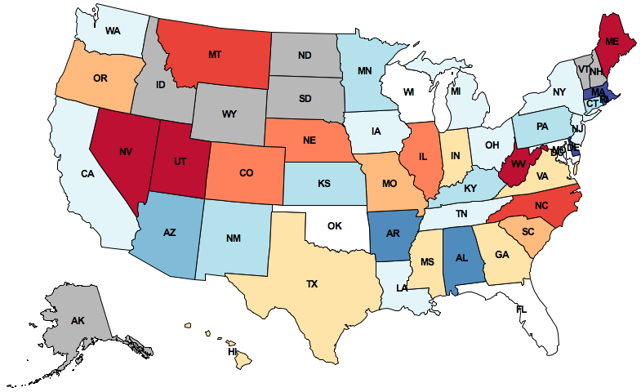

What do people tweet?  
Draw their feelings on a map   
to find the answer.

**Introduction**

In this project, you will develop a geographic visualization of twitter data across the USA. You will need to use dictionaries, lists, and data abstraction techniques to keep track of your intermediate steps and create a modular program. This project uses ideas from Sections 2.1-2.4 of the lecture notes.

The map displayed above depicts how the people in different states feel about Texas. This image is generated by:

1. Collecting public Twitter posts (tweets) that have been tagged with geographic locations and filtering for those that contain the "texas" query word,
2. Assigning a sentiment (positive or negative) to each tweet, based on all of the words it contains,
3. Aggregating tweets by the state with the closest geographic center, and finally
4. Coloring each state according to the aggregate sentiment of its tweets. Red means positive sentiment; blue means negative.

The details of how to conduct each of these steps is contained within the project description. By the end of this project, you will be able to map the sentiment of any word or phrase. There are two alternative zip archives related to this project:

* The [full project](http://inst.eecs.berkeley.edu/~cs61a/fa11/projects/trends/trends.zip), which contains all the starter code and all data (**warning: 81 MB**).
* A [small version](http://inst.eecs.berkeley.edu/~cs61a/fa11/projects/trends/trends_small.zip) that contains all the starter code, but only a small subset of the data. You can complete the project in its entirety using this archive, and you have the option to add more data at the end.

The project uses several files, but all of your changes will be made to the first one.

|  |  |
| --- | --- |
| [trends.py](http://inst.eecs.berkeley.edu/~cs61a/fa11/projects/trends/trends.py.html) | A starter implementation of the main project file. |
| [geo.py](http://inst.eecs.berkeley.edu/~cs61a/fa11/projects/trends/geo.py.html) | Geographic positions, 2-D projection equations, and geographic distance functions. |
| [maps.py](http://inst.eecs.berkeley.edu/~cs61a/fa11/projects/trends/maps.py.html) | Functions for drawing maps. |
| [data.py](http://inst.eecs.berkeley.edu/~cs61a/fa11/projects/trends/data.py.html) | Functions for loading Twitter data from files. |
| [graphics.py](http://inst.eecs.berkeley.edu/~cs61a/fa11/projects/trends/graphics.py.html) | A simple Python graphics library. |
| [ucb.py](http://inst.eecs.berkeley.edu/~cs61a/fa11/projects/trends/ucb.py.html) | Utility functions for 61A. |

**Logistics**

This is a one-week project. You'll work in a team of two people, and you can complete all problems together with your partner.

Start early! Feel free to ask for help early and often. The course staff is here to assist you, but we can't help everyone an hour before the deadline. [Piazza](http://www.piazza.com) awaits. You are not alone!

In the end, you and your partner will submit one project. There are 15 possible points. You only need to submit the file [trends.py](http://inst.eecs.berkeley.edu/~cs61a/fa11/projects/trends/trends.py.html). You do not need to modify any other files for this project. To submit the project, change to the directory where the [trends.py](http://inst.eecs.berkeley.edu/~cs61a/fa11/projects/trends/trends.py.html) file is located and run submit proj2.

**Phase 1: The Feelings in Tweets**

In this phase, you will create an abstract data type for tweets, split the text of a tweet into words, and calculate the amount of positive or negative feeling in a tweet.

**Tweets**

We've gotten you started on an abstract data type for tweets. Right now, we only have the constructor, make_tweet, defined at the top of [trends.py](http://inst.eecs.berkeley.edu/~cs61a/fa11/projects/trends/trends.py.html). make_tweet returns a python dictionary with the following entries:

{'text': <a string, the text of the tweet, all in lowercase>,

'time': <a datetime object, when the tweet was posted>,

'latitude': <a floating-point number, the latitude of the tweet's location>,

'longitude': <a floating-point number, the longitude of the tweet's location>}

**Problems**

**Problem 1** (1 pt). Implement the tweet_words selector. Before we can analyze the feelings in tweets, we need to access its words. We have given you a helper function extract_words that breaks a string up using spaces and returns a list of strings.

tweet_words is a selector function for the tweet abstract data type that returns a list of words contained within the text of the tweet. Call the extract_words function to extract words from a string. You will complete the implementation of extract_words shortly.

**Problem 2** (1 pt). Implement tweet_location, which is a selector function for the tweet abstract data type that returns a position. Positions are another abstract data type, defined at the top of [geo.py](http://inst.eecs.berkeley.edu/~cs61a/fa11/projects/trends/geo.py.html). Make sure that you understand how to manipulate positions; they play an important role in this project.

**Problem 3** (2 pt). Implement a better extract_words function, which takes a string and returns a list of words contained in the string. Assume that a word is any consecutive substring of text that consists only of letters. The string ascii_letters in the string module contains all letters in the ASCII character set.

When you complete this problem, the doctest for extract_words should pass. You can also call the print_sentiment function, which is currently set as the @main function, to print the sentiment values of all words in a line of text.

python3 trends.py "computer science is my favorite!"

**Problem 4** (2 pt). Implement analyze_tweet_sentiment, which takes a tweet (of the abstract data type) and returns a single number averaging the weights of sentiment-carrying words in the tweet, or None if none of the words in the tweet carry a sentiment weight.

Read the docstrings for get_word_sentiment and analyze_tweet_sentiment to understand how the two functions interact.

**Phase 2: The Geometry of Maps**

**Positions**

We will use the position abstract data type to represent geographic latitude-longitude positions on the Earth. The data abstraction, defined at the top of [geo.py](http://inst.eecs.berkeley.edu/~cs61a/fa11/projects/trends/geo.py.html), has the constructor make_position and the selectors latitude and longitude.

In this phase, you will write two functions that together determine the centers of U.S. states. The shape of a state is represented as a list of polygons. Some states (e.g. Hawaii) consist of multiple polygons, but most states (e.g. Colorado) consist of only one polygon (still represented as a length-one list).

**Problems**

**Problem 5** (2 pt). Implement find_centroid, which takes a polygon and returns three values: the coordinates of its centroid and its area. The input polygon is represented as a list of position abstract data types, which are the consecutive vertices of its perimeter. The first vertex is always identical to the last.

The centroid of a two-dimensional shape is its center of balance, defined as the intersection of all straight lines that evenly divide the shape into equal-area halves. find_centroid returns the centroid and area of an individual polygon.

The formula for computing the [centroid of a polygon](http://en.wikipedia.org/wiki/Centroid#Centroid_of_polygon) appears on Wikipedia. The formula relies on vertices being consecutive (either clockwise or counterclockwise, both give the same answer), a property that you may assume always holds for the input.

When you complete this problem, the doctest for find_centroid should pass.

**Problem 6** (2 pt). Implement find_center, which takes a shape (a list of polygons) and returns a position, its centroid.

A shape is a list of polygons. Its centroid can be computed by [geometric decomposition](http://en.wikipedia.org/wiki/Centroid#By_geometric_decomposition). That is, the centroid of a shape is the weighted average of the centroids of its component polygons, weighted by their area.

When you complete this problem, the doctest for find_center should pass.

Once you are finished, remove the @main decorator from print_sentiment and add a @main decorator to draw_centered_map. You should now be able to draw maps with labeled states. The labels are placed at the positions that you return from find_center. For instance, to draw the 20 states closest to California (including California):

python3 trends.py CA 20

**Phase 3: The Mood of the Nation**

**States**

The name us_states is bound to a dictionary containing the shape of each U.S. state, keyed by its two-letter postal code. You can use the keys of this dictionary to iterate over all the U.S. states.

In this phase, you will write functions to determine the state that a tweet is coming from, group tweets by state, and calculate the average positive or negative feeling in all the tweets associated with a state.

**Problems**

**Problem 7** (1 pt). Implement find_closest_state, which returns the two-letter postal code of the state that is closest to the location of a tweet. Use the geo_distance function (provided in [geo.py](http://inst.eecs.berkeley.edu/~cs61a/fa11/projects/trends/geo.py.html)) to calculate the shortest distance in miles between two positions.

When you complete this problem, the doctests for find_closest_state should pass.

**Problem 8** (2 pt). Implement group_tweets_by_state, which takes a list of tweets and returns a dictionary. The keys of the returned dictionary are state names (two-letter postal codes), and the values are lists of tweets that appear closer to that state's center than any other.

When you complete this problem, the doctests for group_tweets_by_state should pass.

**Problem 9** (2 pt). Implement calculate_average_sentiments. This function takes the dictionary returned by group_tweets_by_state and also returns a dictionary. The keys of the returned dictionary are the state names (two-letter postal codes), and the values are average sentiment values for all the tweets in that state.

If a state has no tweets with sentiment values, leave it out of the dictionary entirely. Do not include a states with no tweets, or with tweets that have no sentiment, with a zero sentiment value. Zero represents neutral sentiment, not unknown sentiment. States with unknown sentiment will appear gray, while states with neutral sentiment will appear white.

Once you are finished, remove the @main decorator from draw_centered_map and add a @main decorator to draw_map_for_term. You should now be able to draw maps that are colored by sentiment corresponding to tweets that contain a given term.

python3 trends.py sandwich

python3 trends.py obama

python3 trends.py texas

python3 trends.py "my life"

If you downloaded the small version of the project, you will only be able to map these four terms. If you would like to map any term, you will need to download this [Twitter data file](http://inst.eecs.berkeley.edu/~cs61a/fa11/projects/trends/data/all_tweets.txt) and place it in the data directory of your project.

*Congratulations!* One more 61A project completed.

**Extensions**

These extensions are optional and ungraded. In this class, you are welcome to program just for fun. If you build something interesting, come to office hours and give us a demo.

* Punctuation can be an indicator of sentiment as well. Add an emoticon (smiley) detector that attributes positive sentiment to happy faces :-) and negative sentiment to sad ones.
* In the standard implementation, some tweets are associated with different states than the ones in which they occurred. For example, all tweets from Manhattan are assigned to New Jersey. New Yorkers would be appalled! Replace find_closest_state with a function that finds the state that actually contains a tweet position.
* Different areas of the country may change their sentiment and level of Twitter activity at different times. Can you find a time when the East Coast has more positive vibes than the West Coast? Each tweet has a [datetime](http://docs.python.org/py3k/library/datetime.html) object that should prove useful in this extensions.
* The [graphics.py](http://inst.eecs.berkeley.edu/~cs61a/fa11/projects/trends/graphics.py.html) package supports animation. Use the slide_shape method to have states and dots slide into place.
* [Correct the spelling](http://norvig.com/spell-correct.html) of tweets before you compute their sentiment.